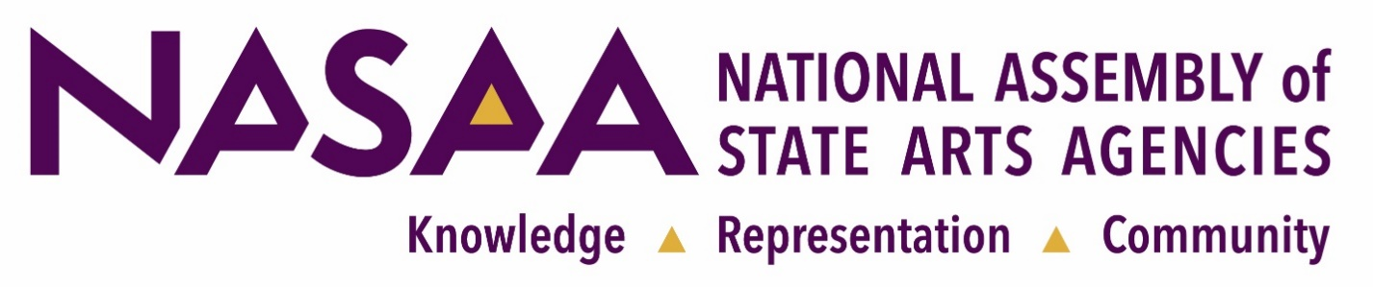
NASAA Assembly 2024

Thank you for your interest in the NASAA Assembly 2024 convening, taking place October 23-26, 2024, in San Juan, Puerto Rico. All state and jurisdictional arts agencies are strongly encouraged to attend this event, which offers tangible benefits to participants:

Visibility: The Assembly helps you promote your state's cultural assets to a national audience.

Assembly 2024 Take-Aways

- Learn how state arts agencies are collaborating with state economic development officials and private partners to develop strategic plans for the creative sector.

- Map the changing legal landscape for grant making and how new compliance requirements may affect state arts agencies in the near future.

- Strategize to develop partnerships that improve public health outcomes.

- Continue the conversation on AI, public policy and the arts with a deeper dive into how artificial intelligence will affect grant application and adjudication processes.

- Hear about the latest data collection strategies state arts agencies are adopting.

- And more!

Applied learning: The Assembly agenda helps state arts agency staff and appointed council/commission members excel at public service. The conference showcases new research, emerging programs and evidence based best practices. Peer sessions facilitate connections with colleagues who can offer practical solutions to common programmatic, administrative and governance challenges. This learning helps Assembly participants to become highly knowledgeable, responsive and accountable.

Community and economic development: The program features community-centered strategies that demonstrate how the arts build community, strengthen resiliency and fuel a region's creative economy. These topics are relevant to every state and U.S. jurisdiction.

Federal relationships: Each state receives a big investment of federal funds from the National Endowment for the Arts (NEA) each year. Attending the Assembly will help you manage your federal grant. A number of NEA staff will be on site, conferring with state arts agencies about federal requirements and providing guidance on NEA priorities. NEA Chair Maria Rosario Jackson, Ph.D., will brief state arts agencies on new opportunities for their agencies to collaborate with the health, human services and transportation sectors. Representatives from other federal agencies will be on hand to discuss ways of developing these resources at the state level.

NASAA Assembly 2024 is a national leadership forum in which every state and jurisdiction participates—and every state and jurisdiction is important. A roll call of states is conducted on the first day and attendance is a matter of public record. We sincerely hope you can join us in San Juan.

To help make this event more affordable, NASAA has negotiated a steeply discounted lodging rate. We also offer team registration discounts and several complimentary meals. If you have any questions, please contact NASAA Learning Services Director Eric Giles, eric.giles@nasaa-arts.org.

